

Practices for Secure Software Report

Table of Contents
Document Revision History 3
Client 3
Instructions 3
Developer 4
1. Algorithm Cipher 4
2. Certificate Generation 4
3. Deploy Cipher 4
4. Secure Communications 4
5. Secondary Testing 5
6. Functional Testing 6
7. Summary 6
8. Industry Standard Best Practices 6

Document Revision History

Version | Date | Author | Comments
1.0 | 6/28/2026 | Veronica Malewski | Module 7 Project Two

Client



Instructions

Submit this completed practices for secure software report. Replace the bracketed text with the relevant information. You must document your process for writing secure communications and refactoring code that complies with software security testing protocols.

- Respond to the steps outlined below and include your findings.
- Respond using your own words. You may also choose to include images or supporting materials. If you include them, make certain to insert them in all the relevant locations in the document.
- Refer to the Project Two Guidelines and Rubric for more detailed instructions about each section of the template.

Developer
Veronica Malewski

Algorithm Cipher
I selected SHA-256 as the hashing algorithm because Artemis Financial needed a checksum to verify that data was not changed during transmission. SHA-256 creates a 256-bit hash value based on the original data. If the data changes even slightly, the hash value also changes, which makes it useful for checking data integrity. SHA-256 is different from encryption because it does not use keys and cannot be reversed back into the original data. Symmetric encryption uses one shared key, while asymmetric encryption uses a public and private key pair. Random numbers may be used when creating encryption keys or certificates, but SHA-256 does not need random numbers to create a checksum. Older algorithms like MD5 and SHA-1 are no longer considered secure because weaknesses have been found over time. SHA-256 is still commonly used because it is stronger and more reliable for file verification, password storage, and secure communication.

Certificate Generation
Insert a screenshot below of the CER file.
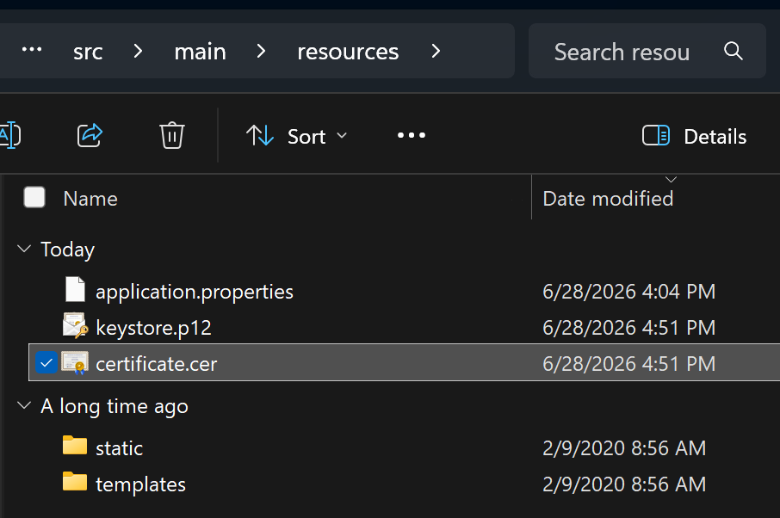

Deploy Cipher
Insert a screenshot below of the checksum verification.
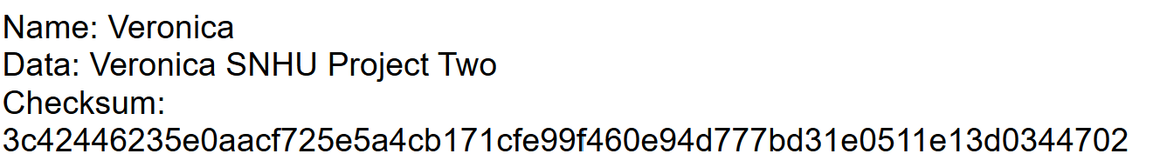

Secure Communications
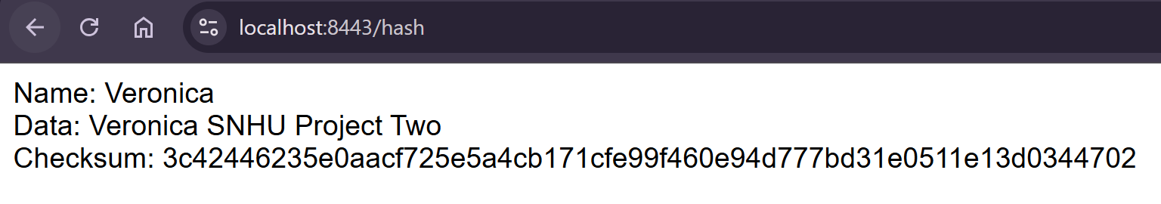
Insert a screenshot below of the web browser that shows a secure webpage.

Secondary Testing
Insert screenshots below of the refactored code executed without errors and the dependency-check report.
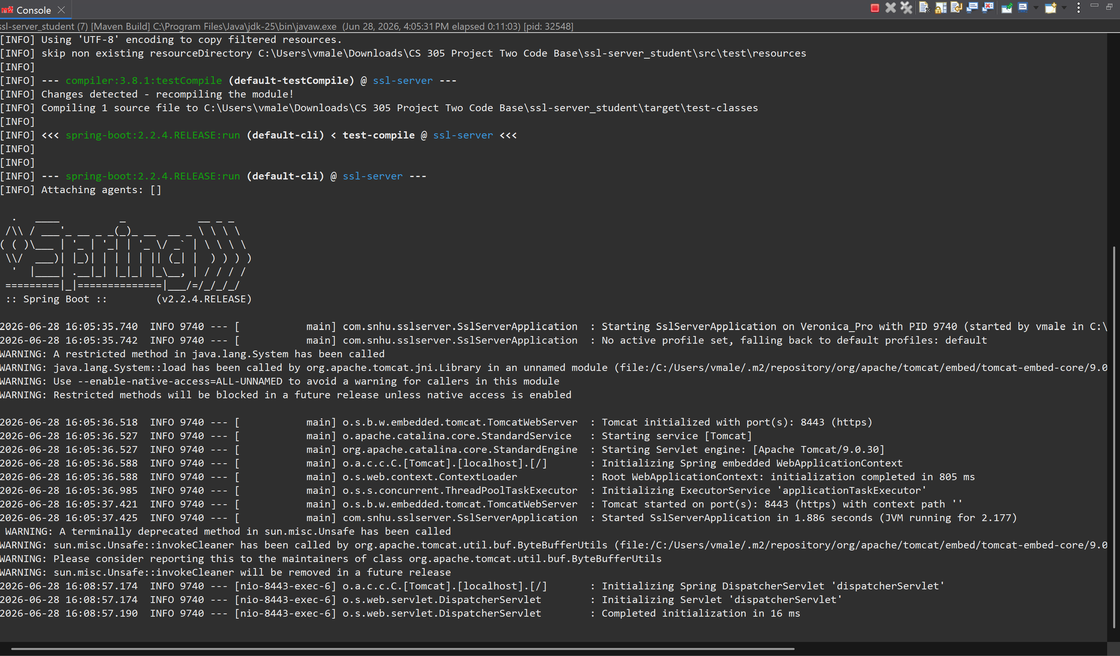

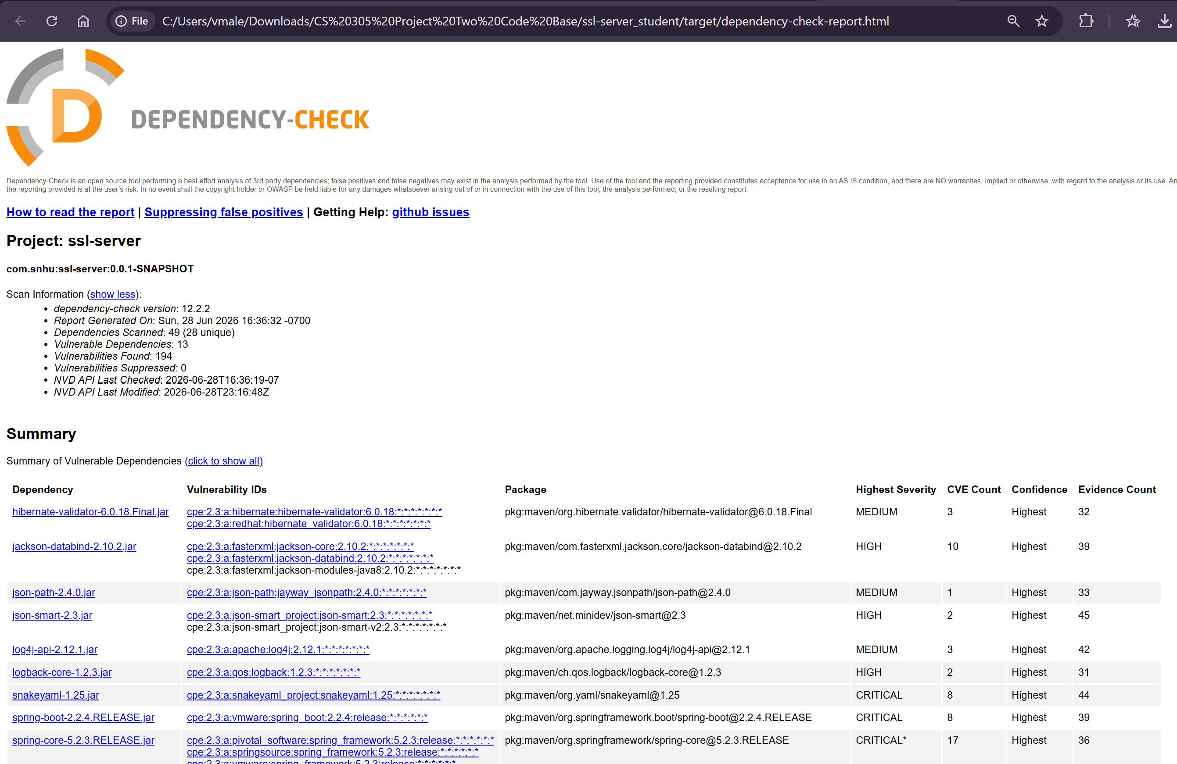

Functional Testing
Insert a screenshot below of the refactored code executed without errors.

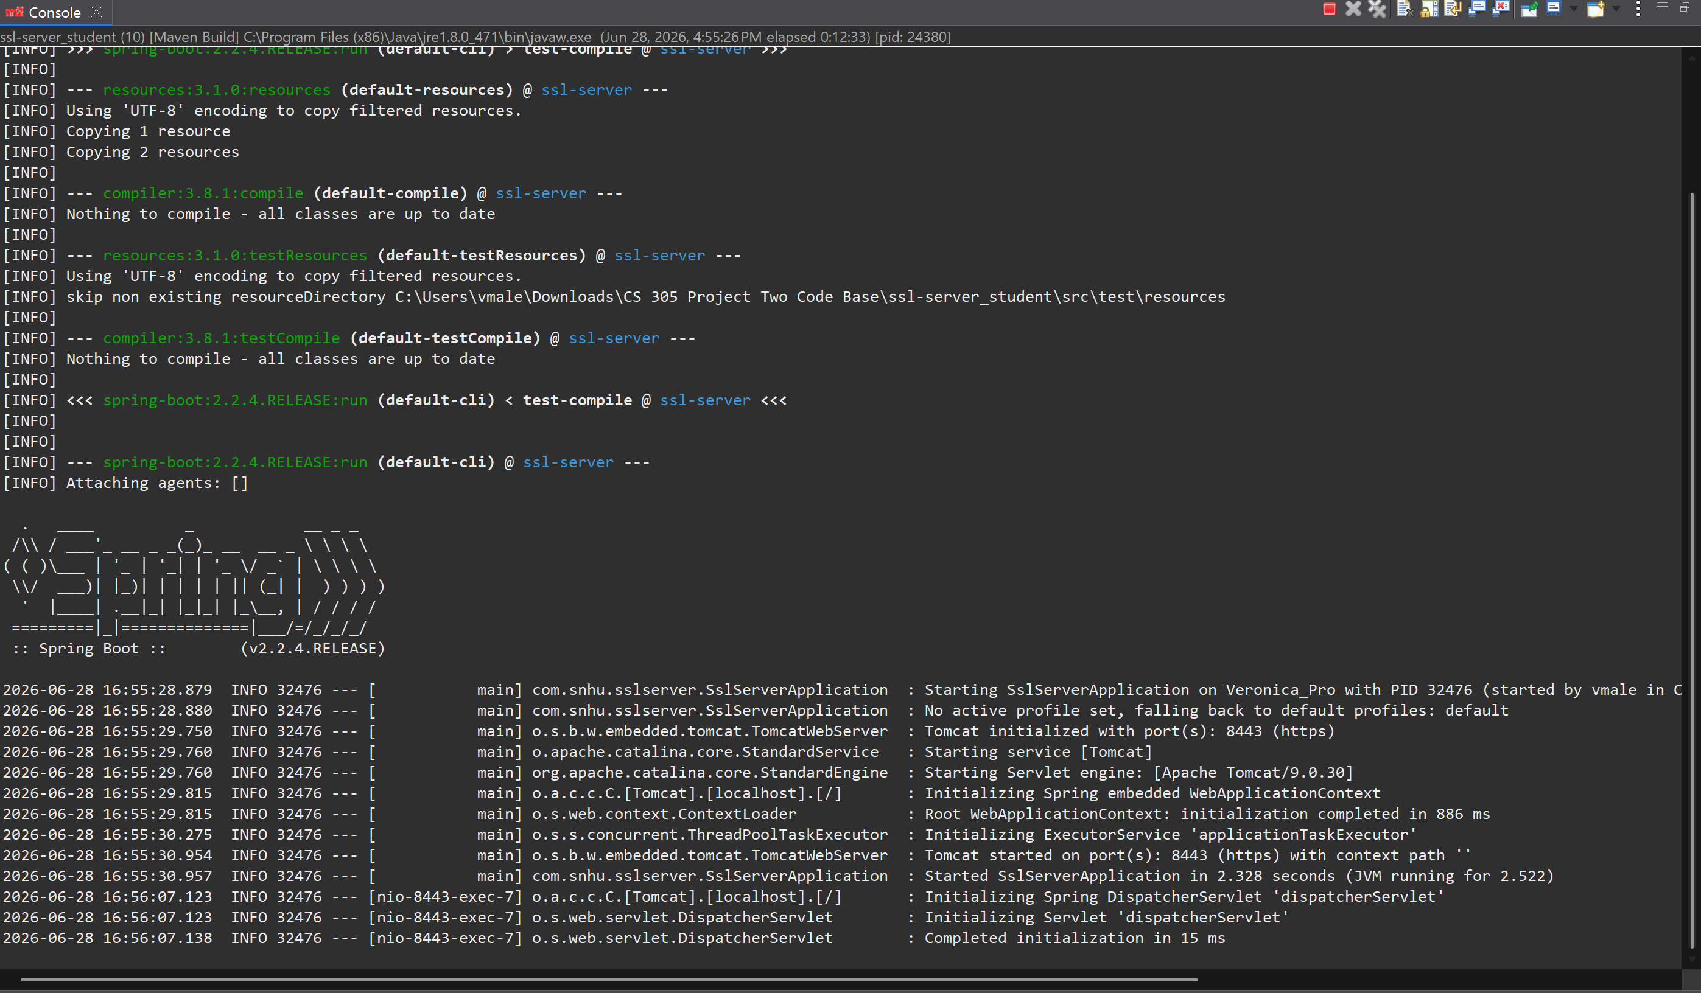

Summary
I refactored the application by adding HTTPS, creating a self-signed SSL certificate, and adding SHA-256 checksum verification. These changes helped secure communication between the client and server and helped verify that transmitted data was not changed. I configured the application to run on port 8443 using HTTPS and verified that the hash page loaded correctly. I also followed the vulnerability assessment process by focusing on secure communication, certificate generation, data integrity, and security testing. After the refactoring was complete, I ran OWASP Dependency-Check to review the project’s third-party dependencies. The scan showed known vulnerabilities in existing dependencies, but the HTTPS, certificate, and checksum changes did not add new issues. Overall, the refactoring added security layers while keeping the application’s original functionality working.

Industry Standard Best Practices
I used industry standard secure coding practices by switching the application from HTTP to HTTPS, creating a self-signed SSL certificate, using SHA-256 for checksum verification, and running OWASP Dependency-Check after the code was refactored. These steps improved the security of the application while keeping the original functionality working. The HTTPS configuration helps protect communication between the client and server. The certificate allows the web page to load securely, and the SHA-256 checksum helps confirm that the data has not been changed. The Dependency-Check scan also helped identify known vulnerabilities in the project’s existing third-party dependencies. For Global Rain and Artemis Financial, these practices help lower security risk, protect customer information, and support safer communication within the application.

